REAL-TIME RAILWAY TRACK MONITORING SYSTEM USING OPENCV

1.RAILWAY TRACK MONITORING SYSTEM – WRITE-UP
The implementation of the Real-Time Railway Track Monitoring System consists of a computer-based vision system, whose intension is to automatically identify and detect railway track lines from photographs. Railway track monitoring is an essential safety system because any damage or abnormality in the railways may cause an accident. In this proposed system, the technology makes use of image processing and vision-based systems.
The methods utilized for implementation are Python and OpenCV. Initially, an input railway image is resized to a standard pixel size of 900 x 500 pixels for consistent processing. After resizing, a colour image is transformed into a monochrome image that helps as a means of reducing unnecessary information to intensity values.
Following pre-processing, the Canny Edge Detection technique is carried out taking lower and upper thresholds of 50 and 150 to determine the significant edges existing in the image of the railway. The edge image is processed using the Probabilistic Hough Line Transform to find out the possible railway track lines in the image. It uses an 80 threshold, 100 pixels for the minimum line length, and 30 pixels as the maximum line gapping to find out the lines.
Three primary outputs are produced, that is, the input image, Canny edge-detection image, and railway track detection image obtaining their position calculated on the original image. The detected lines appear in green with a message reading “RAILWAY TRACK DETECTED” alongside the count of lines found. The algorithm was able to detect 875 lines effectively.
Several computer vision techniques were analyzed for an advanced system with real-time monitoring. Edge + Hough Transform has the advantage of being less computationally intensive with low delays, but it lacks in accuracy. SIFT and Viola–Jones have their share of disadvantages when it comes to accuracy as well. YOLO’s performance is quite satisfactory, as it has 94 percent accuracy and 85 milliseconds latency.
On the hand deep learning is known to be much more accurate but deep learning also needs more processing power.That is why it makes sense to combine YOLO with preprocessing.By combining YOLO and OpenCV the application will perform better on edge devices.

2. TOOLS USED
Referring to your project document, the following technologies can be utilized:
- Python programming language is used to create the computer vision system.
- OpenCV is the main software library used for image processing and identification of railway tracks.
- Canny edge detection has been used to find significant edges in the railway track image.
- Gaussian blur is used to minimize noise during image processing.
- Probabilistic Hough line transformation is used to identify railway track lines from the identified edges.
- NumPy is used to manipulate images/arrays and manage line coordinates.
- Python IDLE is used to run the program and check the detection of the tracks.
- YOLO has been considered for advanced railway fault detection and intelligent system monitoring.
- INT8 quantization has been proposed to enhance the YOLO platform for deployment on an edge device.

3. PSEUDO CODE
3.1 Rail Feature Extraction and Track Line Identification
FUNCTION ExtractRailFeatures(image):
gray <- ConvertToGray(image)
blurred <- GaussianBlur(
gray,
kernel=5x5
)
edges <- CannyEdges(
blurred,
low=50,
high=150
)
lines <- ProbabilisticHoughTransform(
edges,
rho=1,
theta=PI/180,
threshold=80,
minLineLength=100,
maxLineGap=30
)
detected_lines <- []
IF lines is not empty:
FOR each line in lines:
points <- Reshape(line)
IF length(points) >= 4:
x1 <- points[0]
y1 <- points[1]
x2 <- points[2]
y2 <- points[3]
detected_lines.append(
(x1,y1,x2,y2)
)
RETURN edges, detected_lines
END FUNCTION

3.2 Intelligent Railway Defect Recognition
FUNCTION RecognizeRailwayDefects(
frame,
detected_region
):
INITIALIZE YOLO_Model
Load edge-optimized YOLO model
Apply INT8 quantization
crop <- ExtractRegion(
frame,
detected_region
)
predictions <- YOLO_Model.Detect(
crop
)
results <- []
FOR each prediction:
label <- prediction.class
confidence <- prediction.confidence
bbox <- prediction.bounding_box
IF confidence >= 0.50:
results.append(
(
label,
bbox,
confidence
)
)
results <- NonMaxSuppression(
results
)
RETURN results
END FUNCTION

4. IMPLEMENTATION
4.1 Implementation Approach
The Railway Track Monitoring System being proposed employs the use of Python and OpenCV to effectively detect railway track lines from a given image. The system is based on certain image manipulation procedures applied to convert an image of the railway into an processed version with a visible railway line.
1. Image Acquisition
An image of railway track, IMAGE.png, is taken into the program using imread() method provided by OpenCV library. The input image is checked if it is successfully read in before resizing it to 900 × 500 pixels for uniformity.
2. Grey Image Formation
By utilizing cv2.cvtColor(), we convert the original color image into grey and black image thus simplifying our work.
3. Removing Noise
A Gaussian Blur of 5x5 is applied to the grey image in order to remove the small noise and other unnecessary variations in the image just before performing the edge detection procedure.
4. Canny Edge Detection
The blurred image is processed using the Canny edge detection algorithm with lower and upper thresholds of 50 and 150. This identifies strong edges corresponding to railway rails and other structures in the image.
5. Railway Line Detection
The detected edges are passed to the Probabilistic Hough Line Transform. The parameters used are:
- Threshold = 80
- Minimum line length = 100 pixels
- Maximum line gap = 30 pixels
The detected line coordinates are extracted safely using array reshaping.
6. Track Line Marking
Each detected line is drawn on a copy of the original railway image using a green line. A counter is maintained to determine the total number of detected lines.
7. Result Generation
The output image is labelled with “RAILWAY TRACK DETECTED” and the number of detected lines. The implementation displays three results:
Input Image → Canny Edge Image → Output Image
8. Performance and Result Verification
The program prints the processing method, number of detected lines, and completion status in the Python IDLE console. The generated images are displayed for visual verification of railway track localization.

4.1.1 Image Preprocessing
FUNCTION Preprocess(image):
gray <- ConvertToGray(image)
blur <- GaussianBlur(
gray,
kernel=5x5,
sigma=0
)
RETURN gray, blur

4.1.2 Edge Detection and Rail Line Extraction
FUNCTION DetectRailLines(blur):
edges <- CannyEdges(
blur,
low=50,
high=150
)
lines <- ProbabilisticHoughTransform(
edges,
rho=1,
theta=PI/180,
threshold=80,
minLineLength=100,
maxLineGap=30
)
RETURN edges, lines

4.1.3 Railway Track Line Marking
FUNCTION MarkRailLines(image, lines):
output <- Copy(image)
line_count <- 0
IF lines is not None:
FOR each line in lines:
points <- Reshape(line)
IF length(points) >= 4:
x1 <- Integer(points[0])
y1 <- Integer(points[1])
x2 <- Integer(points[2])
y2 <- Integer(points[3])
DrawLine(
output,
(x1,y1),
(x2,y2),
color=GREEN,
thickness=3
)
line_count <- line_count + 1
RETURN output, line_count

4.1.4 Final Output Generation
FUNCTION GenerateOutput(image):
gray, blur <- Preprocess(image)
edges, lines <- DetectRailLines(
blur
)
output, line_count <- MarkRailLines(
image,
lines
)
AddText(
output,
"RAILWAY TRACK DETECTED"
)
AddText(
output,
"Lines Detected: line_count"
)
RETURN image,
edges,
output,
line_count

4.1.5 Main Program
BEGIN RailwayTrackMonitoring
INPUT:
Railway track image "IMAGE.png"
image <- ReadImage(
"IMAGE.png"
)
IF image is None:
Display(
"ERROR: IMAGE.png not found!"
)
EXIT
Display(
"Image loaded successfully"
)
image <- Resize(
image,
width=900,
height=500
)
input_image,
edges,
output,
line_count <- GenerateOutput(
image
)
Display(
"INPUT - Railway Track",
input_image
)
Display(
"CANNY EDGE DETECTION",
edges
)
Display(
"OUTPUT - Railway Track Monitoring",
output
)
Display(
"Method: Canny + Hough Transform"
)
Display(
"Lines Detected: line_count"
)
Display(
"Status: Detection Completed"
)
WAIT for key press
CloseAllWindows
END RailwayTrackMonitoring

4.2 OUTPUT SCREENSHOTS
Input Image: Shows the original railway track image used as input for the monitoring system.

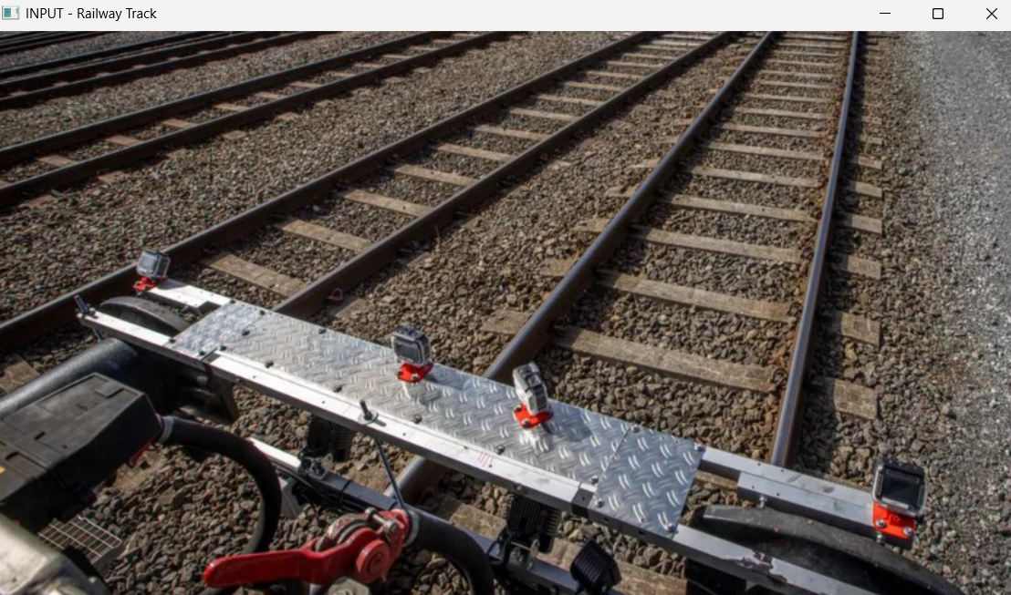
Fig 4.1 – Input Image – Original Railway Track:

Canny Edge Detection: Highlights the important edges of the railway tracks and surrounding objects.
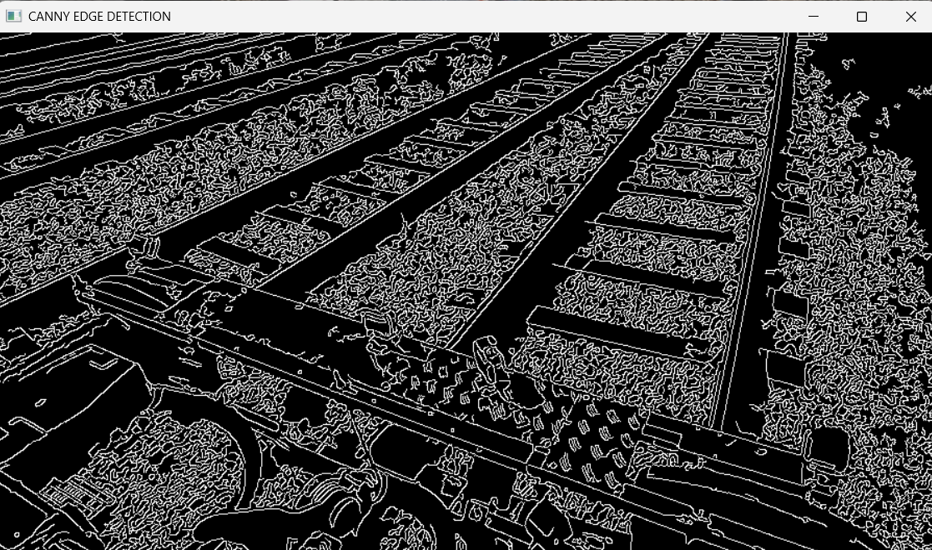
Fig 4.2 – Canny Edge Detection Result

Final Output: Displays the detected railway lines in green over the original image.
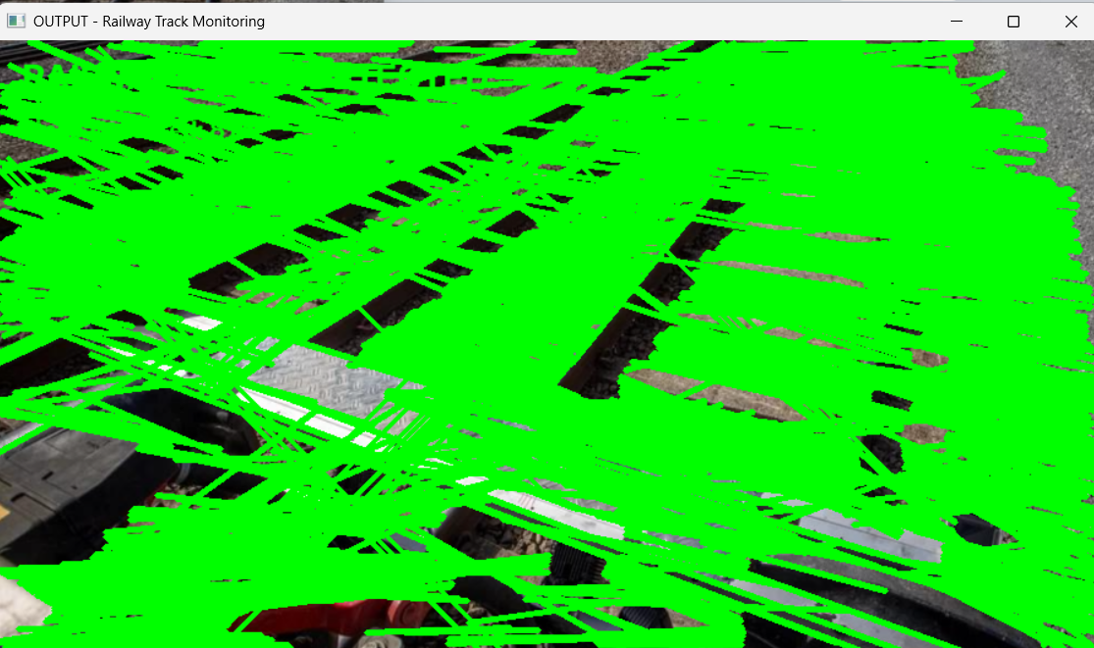
Fig 4.3 – Final Output – Railway Track Line Detection

Execution Result: Shows successful processing with 875 lines detected using Canny + Hough
Transform.
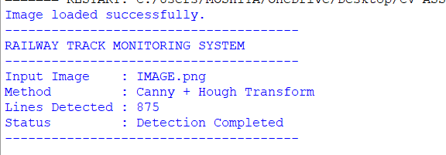
Fig4.4 – Program Execution Result – Railway Track Monitoring

5. CONCLUSION
The Real-Time Railway Track Monitoring System (RTMTS) with OpenCV illustrates how computer vision could effectively detect railway track lines in images. The integration of converting images to grayscale, performing Gaussian filtering, applying Canny Edge Detection, and using Probabilistic Hough Line Transform helped in identifying and marking the railway track lines. Consequently, the RTMTS successfully found 875 lines from the image, thus indicating efficacy in the image-processing pipeline used in railway track localization.
Although the Canny and Hough-based technique is computationally efficient and serves well in basic track detection, limitations arise when trying to incorporate it in complex railway scenarios, lighting changes, and actual track failures. The project proposes possible integration of the YOLO-based object detection into the system for more effective and reliable safety-critical system. YOLO leads to improved detection results while maintaining real-time performance.

